Call it Karma
I don't really believe in karma or fate. I don't think the universe is sentient and I don't believe in God. A belief that your deeds affect your status in this world or the next implies that someone or something is out there keeping score. I do, however, believe that what goes around comes around. This might seem contradictory at first glance but it is really not.
A friend recently sent a video link which started with a man watching a boy pick up some papers a lady had dropped. In the next frame the same man did a positive deed while another observer watched. The whole clip documented a chain of actions spurred by one good deed. This is not fate. This is the realisation of the maxim that one good deed deserves another. If we combine this outlook with the paraphrased idea from the Bible of "Do as you would be done by", a way of thinking and acting starts to emerge.
What happens though, if others don't share this way if thinking? Naturally, sometimes it is going to end badly. There are some odd people in the world. I know. I've met a lot of them on Greyhound. Many times though, it will end well because when it comes down to it, a large chunk of human behaviour is to do with meeting expectations - both your own and the expectations of others.
A practical example of this can be seen in a common training exercise used for counsellors. Each person is given a trait that they wear taped to their head. They do not know what that trait is. The other participants treat that person as if they embody that trait. So, for example, one person may be labelled as 'stupid', another as "popular".

Nine times out of ten, that person will adapt their behaviour by the end of the interaction and start behaving in line with their given trait. If you are told something often enough, the chances are not only will you believe it, but you will also live it.
If we look at that in a positive light, it means good creates good. If you treat someone as though they are a valuable member of society, the chances are they'll be one.
Another example of this is couchsurfing. When I explain couchsurfing to people, many people ask about the safety and security of allowing a complete stranger into your home and life. While some care needs to be taken in who you accept, I have always treated my couchsurfing guests as if they are trustworthy, and I have been rewarded with the corresponding behaviour. In the same way, others have trusted me and I have behaved accordingly. It's hard to explain but there is a certain open-ness to true couchsurfers and I am proud to be part of that group of people.
Every day we are bombarded by bad news. The shows we see on TV highlight the negative happenings in the world - the crime, the wars, and the hate. I believe though, that underneath it all, most people are good.
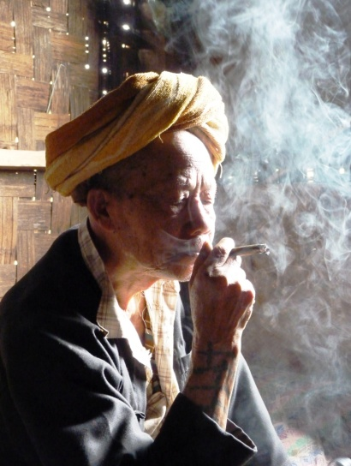
We don't need karma as a concept to validate this. Good begets good. Do good and you will be rewarded with good things. Try it. You might be pleasantly surprised at the results.

The last of the Shamans - Myanmar

